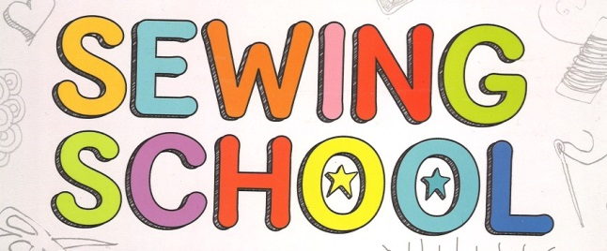

WHAT: Well-behaved students are welcome to sign-up for sewing school with Mr. Lewis' wife, Mrs. Lewis (a licensed classroom teacher and textile artist).

WHEN: Once per week during lunch recess from 12:15-12:45 (usually Thursdays) beginning Oct. 23rd.

WHY: to learn basic sewing skills and make some fun little projects.

WHERE: Room 15

Students will be working with scissors, needles, and get an opportunity to work on a sewing machine. All activities will be supervised.

Kids should bring in a shoe box or other similar container in which to keep their materials. They're also welcome to and encouraged to bring in their own supplies. Suggested items include fabric scissors, sewing needles, thread, pins, fabric, fabric markers, embroidery thread, and old clothing that can be repurposed for new creations. If they can't bring in materials, we'll still make sure they have what they need. Families can also donate materials for the entire group to use.

Participation requires a firm commitment for all 6 to 10 sessions of the class, as well as a commitment to the behavior guidelines.
------------------------------------------------------------------------------------------------------------------

_______ Yes, I would like to participate in Sewing School! I agree to attend all sessions (unless staying home due to illness) and I agree to be safe, respectful, and responsible at all times. I understand that if I am unable to act in a mature manner I will be dismissed from the activity.

Student name: ______________________________ Student Signature: _______________________________

Parent signature: ______________________________________________ Date: ________________________

